**Gencrest Project for Developers**

* Main Modules:
  + **Module 1** - MDO Sales Activity Tracking
  + **Module 2** - Employee Activity Tracking (TM, RBH, RMM, ZH etc.)
  + **Module 3**- SKU Liquidation Management
  + **Module 4** - Sales Order Management
  + **Module 5** - Distributor Module
  + **Module 6** - Employee Performance & Incentive Module
* Web & Mobile View
* Hierarchies:

|  |  |
| --- | --- |
| Sr. No | Role |
| 1 | Market Development Officers (MDO)/ Sales Officers (SO) |
| 2 | Territory Sales Managers (TSM) |
| 3 | Regional Business Heads (RBH) |
| 4 | Regional Marketing Manager (RMM) |
| 5 | Zonal Business Heads (ZBH) |
| 6 | Marketing Head |
| 7 | VP – Sales and Marketing |
| 8 | Managing Director |
| 9 | CFO & Finance Manager |
| 10 | CHRO & HR Manager |

* **LIQUIDATION MODULE: DATA FROM ERP/NON ERP**

|  |  |  |  |
| --- | --- | --- | --- |
| **MODULE** | **REQUIREMENT** | **ERP/ NON -ERP** | **Comments by Gencrest Netsuite Partner – Deloitte** |
| **Liquidation Tracker** | Customer wise locational mapping :Zone (8) – Regions (16/17) – Territory (74) | ERP | Custom fields/classifications on Customer record (Location, Region, Zone hierarchy) |
| **Liquidation Tracker** | Customer wise details : code, name, address (firm name, location, town, taluka,district , state and pin code), phone number | ERP | Standard Customer Master |
| **Liquidation Tracker** | Status of activation :Active/ Inactive/Blocked | ERP | Customer Status (Active/Inactive) + Workflow for Blocked |
| **Liquidation Tracker** | Stock Mapping: Product code – Product Name – SKU ,Opening Stock – Current Stock - Billing date, Volume, Value (Cumulative Net on a real -time basis/chosen date basis) | ERP | Standard Inventory Balances, Saved Search |

**MDO VIEW ON GENCREST PLATFORM:**

* **MDO Logs in to Mobile app or Web version using their Evoke HR credentials. Gets to see the following:**
* **Monthly Activity:** Planned I Done I % age pending I % completed
* **Liquidation**

**DEVELOPMENT OF LIQUIDATION MODULE - Important Points for MDOs**

* Customers to be mapped to respective MDO/TMS
* Customer wise list of location – Zone (8) – Regions (16/17) – Territory (74) from ERP
* Customer wise details - code, name, address, phone number from ERP
* To display status of activation – (E.g. Active/ Inactive/Blocked from ERP)
* Product code – Product Name – Opening Stock – Current Stock - Billing date, Volume, Value (Gross and Net after returns) from ERP.
* MDO to be able to add retailer linked to the particular Customer
* Filters to be configured as per Gencrest’s Requirement
* Allow Open Edit Access – Only the following users - MDO/SO ,TM, RBH, RMM, ZBH to update liquidation data for any dealer.
* Cross-hierarchy editing of dealer liquidation data—where any user, regardless of assignment, can update records (same point as above)
* Allow access to MDOs to update Liquidation for Customers in their state only
  + State level access - MDO/SO ,TM, RBH, RMM, ZBH
  + Exception – Option to map RMM/ZBH to multiple states
  + Head Office Staff (HO) - Access to all states
* Mandatory – Distributor to be able to Esignature for uploading Letterhead for validation – with timestamp

**MDO FLOW**

**STEP 1:**

* **MDO Clicks "Liquidation" tab on mobile app/web**
* **Sees Cumulative Liquidation data for All customers assigned to him**

**TABLE 1:**

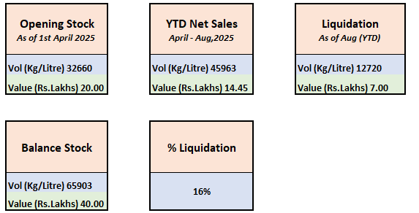

* *VALUE LOGIC - (Vol x Invoice Price (Per Kg/Ltr as per standard pack))
* **Balance Stock = Opening Stock 32 + YTD Sales 45 – Liquidation 12
* *** % Liquidation = Liquidation 12 /opening 32 + YTD net sales 45

**STEP 2**

* **MDO Visits Distributor assigned to him**
* **Sees Distributors Overall statistics: Example: 1325 - SRI RAMA SEEDS AND PESTICIDES**

**TABLE 2**

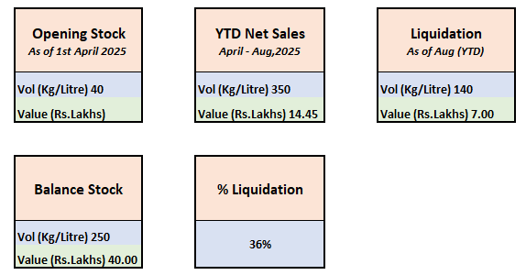

**Clicks on “Enter Current Stock”**

* **When MDO/User Clicks “Enter Current Stock”**
  + Show Product & SKU wise Last Balance as per ERP
  + MDO/User will now enter the Product & SKU wise “Current Stock” (as on todays date)
    - MDO/User is supposed to verify all Product & SKU wise “Current stock”. In case, they miss any Product / SKU details intentionally or as oversight an alert / notification to be generated. Example: ***"There are 8 additional products where entries are pending (Only if there is balance stock against those)***
  + If there is no difference in the Last Balance and the Current Stock – Only E-SIGN Needed
  + In case of a difference – Check If “Sold to Retailer” OR “Sold to Farmer” OR “Return”
    - If Sold to Retailer - Add Retailer details (If new, Or auto populate retailer details if he is an existing retailer
      * **Example:** If the Last Balance stock is **90**, and the current stock is **50**, details of the Balance **40** to be tracked (Retailer 1 – SKU wise QTY, Retailer 2 – SKU wise QTY or Farmer – SKU Wise QTY)
      * Verification - Only E-SIGN and No Letterhead Declaration needed
      * The MDO/ Users should be shown a notification informing them about the pending task to take liquidation from the retailer.
    - If Sold to Farmer – No details & No verification needed
    - If Return - E-SIGN or Letterhead Declaration needed **(Asad, pls ratify this point)**
  + **SCENARIO:** In case of RETURNS identified during a future visit to distributor
    - Current Stock as on last visit – 50 Kg
    - During the current visit, the stock is increased to say 75 Kg , we need to factor the 25 KG difference
      * 25 Kg could be return from Retailer(s)
      * View Retailer wise records and modify (we need to visualize how this will work)
      * Show an alert or notification to MDO/Users about this change

**STEP 3:**

* **MDO/User Visits Retailer A** 
  + MDO Sees Product and SKU wise list
  + Sees QTY assigned by Distributor SRI RAMA SEEDS AND PESTICIDES to RETAILER A **(40 Kg)**
  + Inputs current stock **(20 Kg)**
  + Verification (Sign)
  + Inputs final liquidated stock to farmer **(20 Kg)**
  + Option of return remains open thus true liquidation for distributors cannot be shown unless there is liquidation to farmer at retailer level and stock is finished.